Sports Premium in 2016/2017
National Vision: ALL pupils leaving primary school physically literate and with the knowledge, skills and motivation necessary to equip them for a healthy, active lifestyle and lifelong participation in physical activity and sport.
Objective: To achieve self-sustaining improvement in the quality of PE and sport in primary schools against 5 key indicators:
- the engagement of all pupils in regular physical activity – kick-starting healthy active lifestyles
- the profile of PE and sport being raised across the school as a tool for whole school improvement
- increased confidence, knowledge and skills of all staff in teaching PE and sport
- broader experience of a range of sports and activities offered to all pupils
- increased participation in competitive sport Caslon Vision:
 To generate and maintain enthusiasm and enjoyment in PE
 To promote the importance of a positive attitude to health, fitness and hygiene in an active lifestyle  To develop pupils knowledge of a range of types of physical activity, their principles and related vocabulary   To enable teachers to develop and enhance their confidence and ability to deliver high quality PE lessons.
 To develop the fitness, co--‐ordination, control and range of movement of pupils
 To enable pupils to understand and use safe practice and fully understand its importance in PE
 To enable pupils to acquire and develop a wide range of personal qualities such as perseverance, interdependence and good sportsmanship
 To raise pupils levels of self--‐esteem and confidence
 To enable pupils to work well, whether as an individual or as part of a team
 To enable pupils to develop core skills, such as verbal communication, time keeping, etc.
 To enable all pupils, regardless of ability/ disability, to play an active role in PE.
Sport Premium Grant Awarded
Total Number On Role |  | 203
Sport Premium Lump Sum | £8000.00
Additional funding based on eligible pupil premium | 173 pupils x £5 each £865.00
Total Sport Premium for 2016-17 based on carry over from the previous financial year of £0 | £8865.00

Academic Year: 2016/ 2017 |  | Total fund allocated: £8865
A | B | C | D | E | F | G | H
PE and Sport  Premium Key  Outcome  Indicator | School Focus/ planned Impact  on pupils and staff | Actions to Achieve | Planned Funding | Actual Funding | Evidence | Actual  Impact  (following Review) on pupils | Sustainability/ Next Steps
1. the engagement of  all pupils in regular physical activity – kickstarting healthy active  lifestyles | To generate and maintain enthusiasm and  enjoyment in PE  To promote the importance of a positive attitude to health, fitness and hygiene in an active lifestyle | Support and involve the least active children by extending school sports clubs, holiday clubs and Change4Life clubs.  Support breakfast club with more varied equipment for morning activity sessions  (change4life)  Whole school healthy eating programme to support current cooking programme. See food dudes/ www.phunkyfoods.co.uk/ www.schoolfoodplan.com/plan | £500  Change  4  life  sports bag  and  resources  for  breakfast  club |  | Increased attendance to breakfast club.  Increased school attendance of targeted pupils.  Introduction of Sports Respects your rights UK |  | The increase numbers at extra-curricular clubs and change for life clubs will improve the children’s attitude to developing and maintain a love of PE and healthy lifestyle.  This will in turn  make them  more likely to make healthy lifestyle choices and engage in more physical activity.

2. the profile of PE and sport being raised across the school as a tool for whole school  improvement | To enable pupils to develop core skills, such as verbal communication, time keeping, etc.  To enable all pupils, regardless of ability/ disability, to play an active role in PE.  To raise pupils levels of self--esteem and  confidence | Staffing for release of PE lead to attend Dudley ‘Teach Meets’ for PE  Replacement of and purchase of PE equipment. | £200 Staff  cost  £550 |  | School  sportsmark  Staff  questionnaire  Pupil voice  PE display  board  PE section of  website |  | Ensure school maintains strong links with local schools to continue to participate in competitions.  Continue to develop pupils skills in various sports to ensure participation possible.
3. increased confidence, knowledge and skills of all staff in teaching PE  and sport | To develop pupils knowledge of a range of types of physical activity, their principles and related  vocabulary  To enable teachers to develop and enhance their | Hiring specialist, qualified sports coaches to work alongside and up skill teachers when teaching PE.  Over a 7-8 week period, teachers team teach with specialist coaches and adapt planning for subsequent lessons. Joint assessment sessions to be planned. Feedback between coach and teacher to | £4940  Your Sport Curriculum support |  | Year group planning  folders  Working relationship between coaches and  teachers  Observations of teaching and learning. |  | Using specialist sports coaches  to up skill teachers.  Cascade up-  skilling of teachers to teaching assistant and other stakeholders

 | confidence and ability to deliver high quality PE lessons.  To develop the fitness, co--ordination, control and range of movement of pupils  To enable pupils to understand and use safe practice and fully understand its importance in  PE | improve and enhance delivery of Physical  Education  This academic year our sports coach will work directly with Reception, Year 2,3 and 4.  Year 1 teaching post currently under transition.  Year 5 and 6 will receive high quality PE sessions from full time internal teaching member of staff who has 14 years experience of teaching PE in secondary schools. |  |  | Staff  Questionnaires  Pupil voice  Coach  questionnaires  % of pupils achieving end of Key Stage attainment targets |  | such as parent helpers, behaviour support mentor  and site manager.
4. broader experience of a range of sports and activities offered to all pupils | To generate and maintain enthusiasm and  enjoyment in PE  To develop pupils knowledge of a range of types of physical activity, their principles | In response to pupil voice and to increase the % of girls at extra-curricular clubs, the hiring of a dance teacher for curricular support and extracurricular.  Develop a partnership with  Woodfield school and ‘A sporting Chance’ to activities based around the area of Outdoor education, | 36 curricular sessions (6 per year group and 12 extra curricular sessions through Dizzy Dance academy. |  | afterschool clubs and lunch time training sessions timetabled in preparation for competitive events

 | and related vocabulary | specifically climbing walls, skiing and Junior Duke of Edinburgh programme. | £1200
5. increased participation in competitive sport | To enable pupils to acquire and develop a wide range of personal qualities such as perseverance, interdependence and good sportsmanship     To raise pupils levels of self--esteem and confidence     To enable pupils to work well, whether as an individual or as  part of a team | Hiring of Specialist coach to train pupils, work alongside stakehoilders, organise and officiate competitive fixtures.  Affiliation with Stourbridge School Football League.  Affiliation to Dudley School  Sports Association  Travel to and from  competitions – only when it is impossible to acquire a minibus or transport from a partner school’s minibus.  Staffing for participation in inter school competitions for Tag Rugby and Athletics. | 38  sessions  £950  £25  £20  £200  £300 |  | Sportsmark  Gold  after-school clubs and lunch time training sessions timetabled in preparation for competitive  events |  | Ensure school maintains strong links with local schools to continue to participate in competitions.  Continue to develop pupils skills in various sports to ensure participation possible.  Stakeholders who work alongside the coach will be trained in delivering extra curricular clubs and where appropriate and safe develop their officiating of competitive sports.

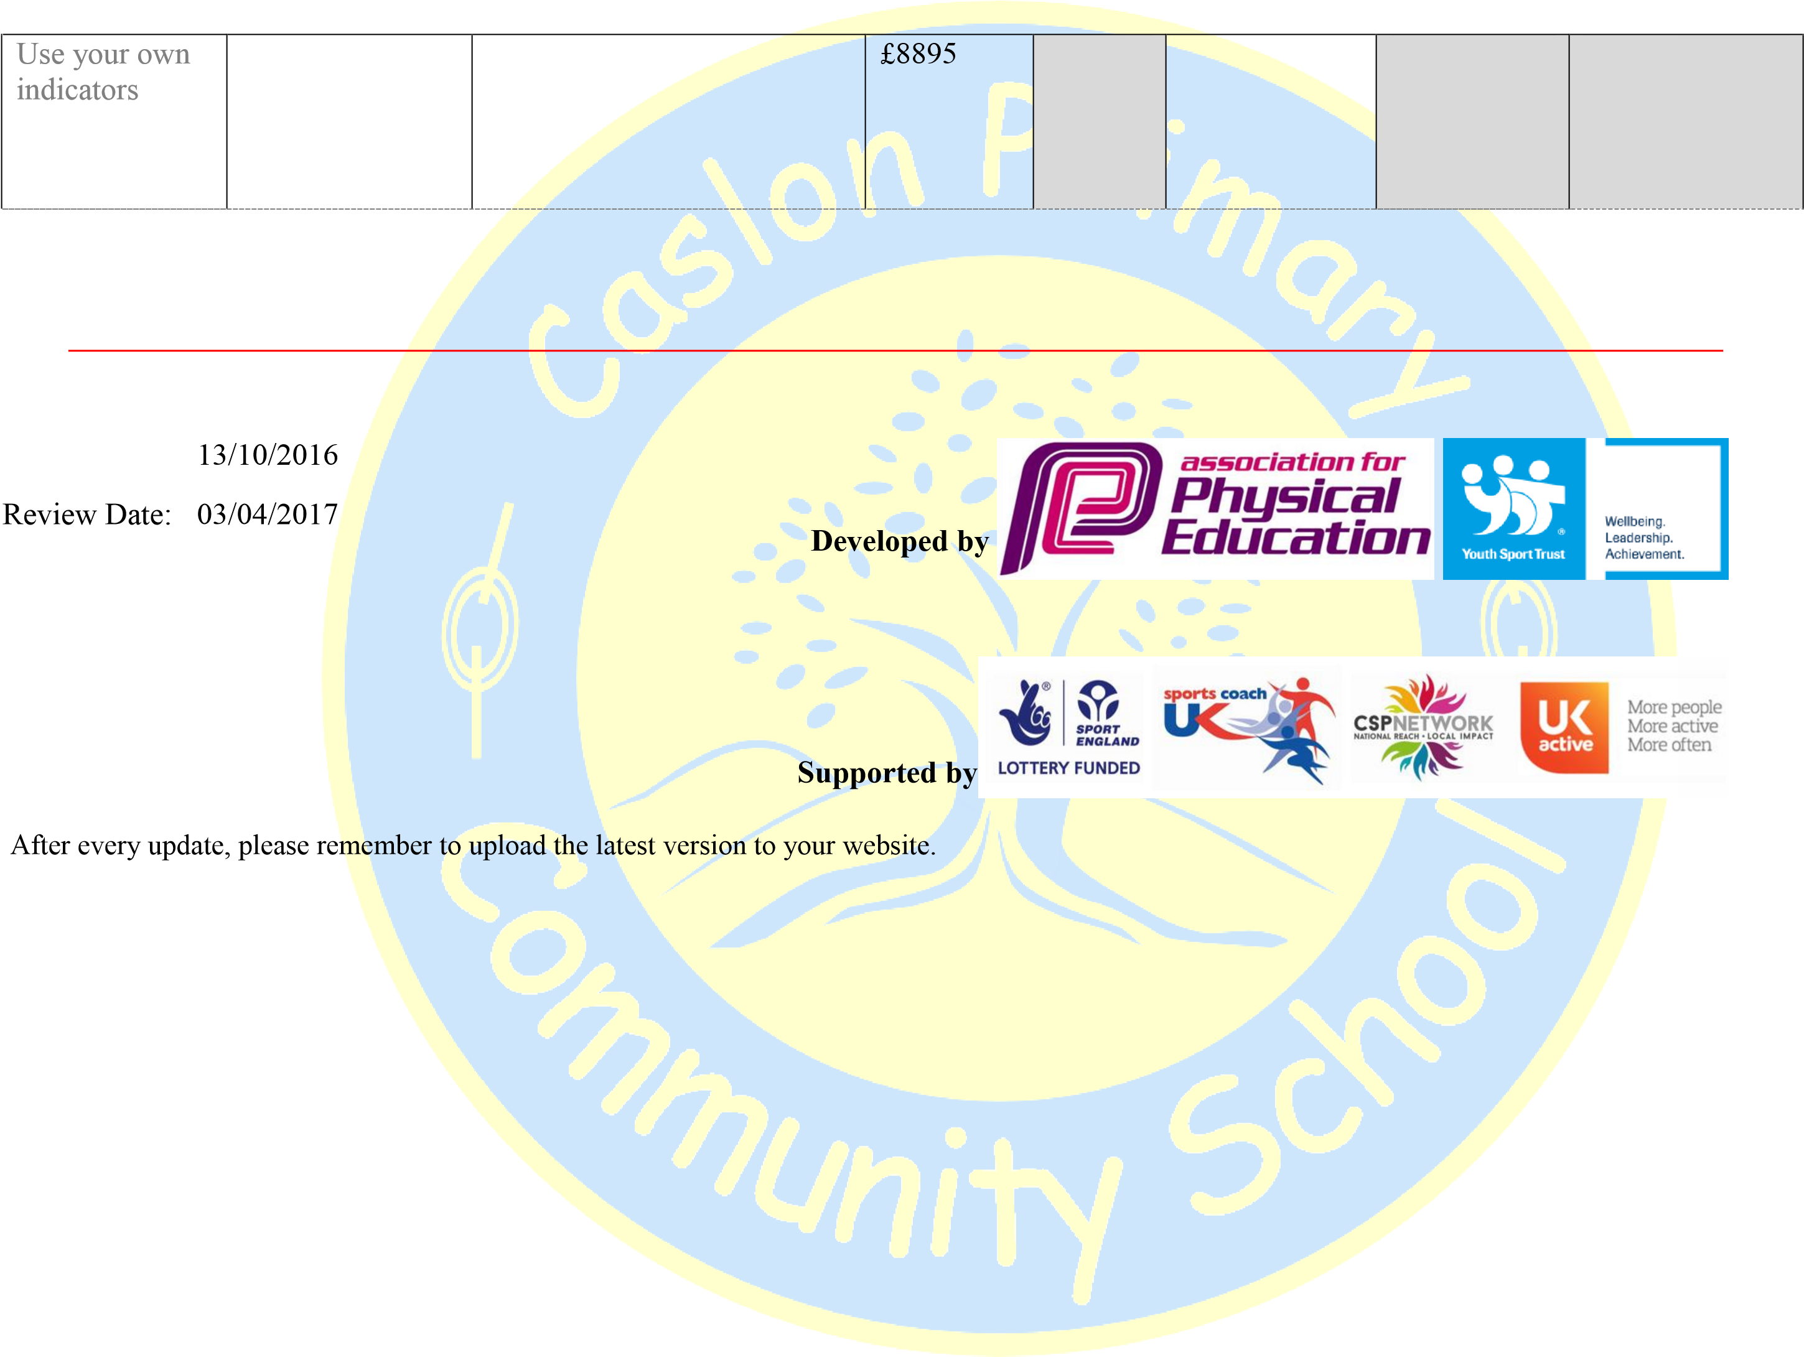
Completed by : Mr T Wagstaff
Date:

