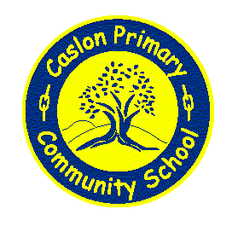

Reception Class
2017
Parent
Handbook

Contents
- Transition to Reception
- Structure of the Day
- Routines
- Letters and Sounds
- Home Reading
- Lunch boxes
- Arriving at School.
- Early Years Framework
- Principles of Development Matters
- Early learning Goals
- Early Years Pupil Premium

Transition
This is the process of preparing yourself and your child for life in Reception class.
- Visits to school for those new to Caslon.
- Meeting for parents.
- Transition days – experience Reception style activities.
- Spend lunch times outside with other children.
- 1 free lunch for parent and child in dining hall – week beginning 26th June.
- Staggered entry in September – half days for first 2 weeks. Half numbers enables teacher getting to know pupils better and higher staff to pupil ratios initially.

Reception Day
Dough Disco
teacher
led activities

healthy snacks
Kinetic letters
Guided reading
physical play
Vygotsky Maths
free choice
painting
role play area
EAL groups

sand and water
letters and sounds
Letters and Sounds
- Daily teaching programme in groups of approximately 8-10.
- Puts foundations of reading in place through teaching sounds, blending and segmenting.
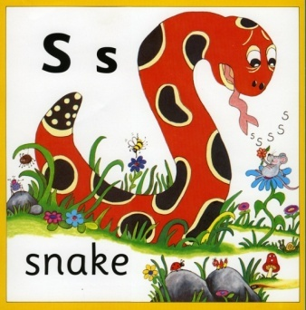
- We use ‘Jolly Phonics’ actions to teach the initial sounds.
- New sounds are taught daily and simple words are read.
- A variety of Oxford Reading Tree Books are used to reinforce learning and give opportunity for pupils to apply their skills.
- Letter formation rhymes are taught to help children learn to form letters correctly from the very beginning.

Home Reading
- Every child has a weekly reading book (when teacher deems they are ready) linked to their stage in Letters and Sounds – which they shall be able to read supported by an adult.
  - Parent home/school book to write comments in.
  - Increase number of books as child learns to read.
  - Books will be changed once child has read book 3 times and reading record has been signed 3 times by a parent.
  - Guided Reading Groups take place once a week for children whose skills are rapidly developing.
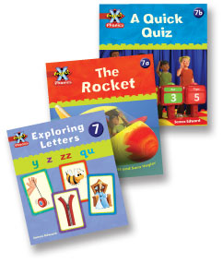
  - Children whose skills are emerging will be heard to read on a one-to-one.

PE
- Physical development is part of the whole week:
    - Dough gym
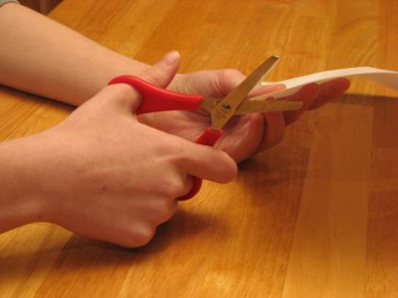
    - Outdoor play
    - Adventure playground
    - Equipment
    - Scissors and one handed tools

PE session days
- See school uniform policy
- Earrings must be taken out – Dudley LA policy.
- Compulsory involvement

Healthy Lunches
Part of our responsibility as a school is to educate our pupils about health and well being.

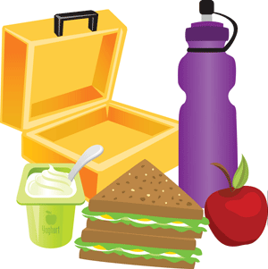
Providing you child with healthy lunchbox:
  - Sandwich/similar
  - Fruit
  - Dairy
  - 1 treat
- Healthy drink
Free Dinner Options:
School sandwiches - cheese, ham, tuna or egg
Jacket Potato – choice of fillings
Hot dinner – halal, vegetarian or vegan available
Packed Lunch – from home.
School dinners are FREE until the end of Year 2.
Water bottles should be brought to school daily.
Starting in September.
We operate staggered entry to support children in making the transition from half days in Nursery to full time education.
Staggered entry
Over the first two weeks – first week your child will have either morning or afternoon sessions.
In the second week, your child will have the opposite (if deemed ‘ready’ for fulltime, class teacher will consult parents).

Morning sessions arrangements
At 8:40 bring pupils through bottom playground, up steps and into classroom from door by field. They will be staying for lunch. Collect pupils from school office at 12:45.

Afternoon session’s arrangements
Bring pupils to classroom via school office at 1:00 and wait to collect them on the bottom playground at 3:00pm. Class teacher will bring them out.

Any problems arrising from these arrangements, please speak to the class teacher/s.
Learning Journeys
What is it?
A record of all milestones reached by your child, significant events, and words they say or do that show a new level of development has been reached.

Who contributes to it?
- Parents – e-mail photos and new skills/knowledge to early-years@caslon.dudley.gov.uk .
- Children – anything they wish to be included (within reason!).
- Staff - daily observations, work completed, photos.

Why is it needed?
At key points through the year, our staff team assess the progress of each child. The evidence in the Learning Journey supports our judgements. Your knowledge is also key to helping us make those judgements as accurate as possible.

How do we collect evidence?
- Post-it notes
- Photographs
- Samples of work

Development Matters
A Unique Child

Positive
Relationships

Enabling
Enviroments

Learning and
Development
₊
₊
₊

Contributions to Learning

Characteristics of Effective Characteristics of Effective Learning
Playing and exploring – engagement
Finding out and exploring
Playing with what they know
Being willing to ‘have a go’
Active learning – motivation
Being involved and concentrating
Keeping trying
Enjoying achieving what they set out to do
Creating and thinking critically
Having their own ideas
Making links
Choosing ways to do things
At the end of Reception year, a paragraph must be reported about each child about their characteristics of effective learning.
We communicate your child’s progress through Learning Passports termly.

Areas of Learning and Development | Aspect
Prime Areas
Personal, Social and Emotional Development | Making Relationships
 | Self-confidence and self-awareness
 | Managing feelings and behaviour
Physical Development | Moving and handling
 | Health and self-care
Communication and Language | Listening and attention
 | Understanding
 | Speaking
Specific Areas
Literacy | Reading
 | Writing
Mathematics | Numbers
 | Shape, Space and measure
Understanding the World | People and communities
 | The world
 | Technology
Expressive Arts and Design | Exploring and using media and materials
 | Being imaginative
The Early Learning Goals
These are only used in the Summer Term against which we must assess each child against the standard as either;
Emerging,
Expected
Exceeding.
These are shared with parents in an End of Year Report.

The Early Learning Goals:

Prime Areas
Personal, Social and Emotional Development
Making relationships – Children play co-operatively, taking turns with others. They take account of one another’s ideas about how to organise their activity. They show sensitivity to others’ needs and feelings and form positive relationships with adults and other children.
Self-confidence and self-awareness – Children are confident to try new activities, and say why they like some activities more than others. They are confident to speak in a familiar group, will talk about their ideas, and will choose the resources they need for their chosen activities. They say when they do or don’t need help.
Making relationships and behaviour – Children talk about how they and others show feelings, talk about their own and others’ behaviour and its consequences, and know that some behaviour is unacceptable. They work as part of a group or class, and understand and follow rules. They adjust their behaviours to different situations, and take changes of routine in their stride.

Communication and Language
Listening and Attention – Children listen attentively in a range of situations. They listen to stories, accurately anticipating key events and respond to what they hear with relevant comments, questions or actions. They give their attention to what others say and respond appropriately, while engaged in another activity.
Understanding – Children follow instructions involving several ideas or actions. They answer ‘how’ and ‘why’ questions about their experiences and in response to stories or events.
Speaking – Children express themselves effectively, showing awareness of listeners’ needs. They use past, present and future forms accurately when talking about events that have happened or are to happen in the future. They develop their own narratives and explanations by connecting ideas or events.

Physical Development
Moving and Handling – Children show good control and co-ordination in large and small movements. They move confidently in a range of ways, safely negotiating pace. They handle equipment and tools effectively, including pencils for writing.
Health and self-care – Children know the importance for good health of physical exercise and a healthy diet and talk about ways to keep healthy and safe. They manage their own basic hygiene and personal needs successfully including dressing and going to the toilet independently.

Specific Areas:
Literacy
Reading – Children read and understand simple sentences. They use phonic knowledge to decode regular words and read them aloud accurately. They also read some common irregular words. They demonstrate understanding when talking with others about what they have read.
Writing – Children use their phonic knowledge to write words in ways which match their spoken sounds. They also write some irregular common words. They write simple sentences which can be read by themselves and others. Some words are spelt correctly and others are phonetically plausible.

Mathematics
Numbers – Children count reliably with numbers from one to 20, place them in order and say which number is one more or one less that a given number. Using quantities and objects, they add and subtract two single-digit numbers and count on or back to find the answer. They solve problems, including doubling, halving and sharing.

Shape, Space and measure – Children use everyday language to talk about size, weight, capacity, position, distance, time and money to compare quantities and objects and to solve problems. They recognise, create, describe pattern. They explore characteristics of everyday objects and shapes and use mathematical language to describe them.

Understanding the world
People and Communities - children talk about past and present events in their own lives and in the lives of family members. They know that other children don’t always enjoy the same things, and are sensitive to this. They know about similarities and differences between themselves and others, and among families, communities and traditions.

The world - children know about similarities and differences in relation to places, objects, materials and living things. They talk about the features of their own immediate environment and how environments might vary from one another. They make observations of animals and plants and explain why some things occur, and talk about changes.
Technology - children recognise that a range of technology is used in places such as homes and schools. They select and use technology for particular purposes.

Expressive Arts
Exploring and using media and materials - children sing songs, make music and dance, and experiment with ways of changing them. They safely use and explore a variety of materials, tools and techniques, experimenting with colour, design, texture, form and function.
Being imaginative - children use what they have learnt about media and materials in original ways, thinking about uses and purposes. They represent their own ideas, thoughts and feelings through design and technology, art, music, dance, role-play and stories.

