

Schools must use the funding to make additional and sustainable improvements to the quality of PE and sport they offer. This means that you should use the Primary PE and Sport Premium to:

- develop or add to the PE and sport activities that your school already offers
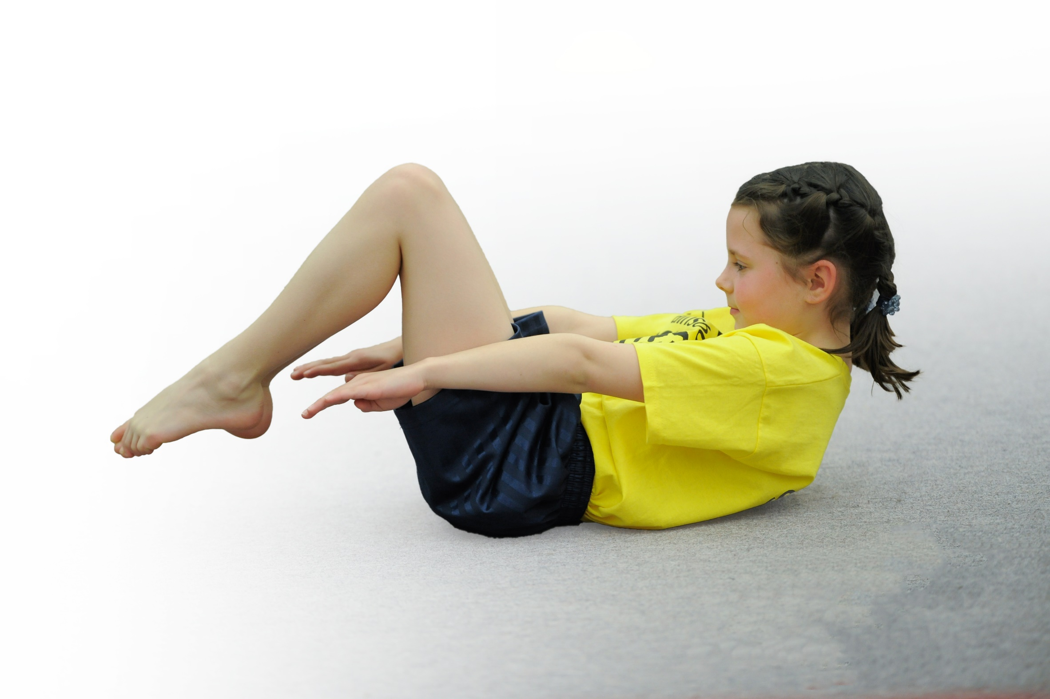
- build capacity and capability within the school to ensure that improvements made now will benefit pupils joining the school in future years

Please visit gov.uk for the revised DfE guidance including the 5 key indicators across which schools should demonstrate an improvement. This document will help you to review your provision and to report your spend. DfE encourages schools to use this template as an effective way of meeting the reporting requirements of the Primary PE and Sport Premium.

We recommend you start by reflecting on the impact of current provision and reviewing the previous spend.
Under the Ofsted Schools Inspection Framework, inspectors will assess how effectively leaders use
the Primary PE and Sport Premium and measure its impact on outcomes for pupils, and how effectively governors hold them to account
for this.

Schools are required to publish details of how they spend this funding as well as on the impact it has on pupils’ PE
and sport participation and attainment.
We recommend regularly updating the table and
publishing it on your website as evidence
of your ongoing review into how you are using the money
to secure maximum, sustainable impact. To see an example of how to complete the table please click HERE.

Support for review and reflection - considering the 5 key indicators from DfE, what development needs are a priority for your setting and your students now and why? Use the space below to reflect on previous spend, identify current need and priorities for the future.

Key achievements to date: | Areas for further improvement and baseline evidence of need:
- Increased amount of lessons observed in PE are graded good  - Teacher self-audit shows increased confidence in delivering PE  - Increased number of children accessing out of hours clubs  - Much improved attendance at competitive fixtures  - Increased links to clubs | - School should be now be planning to reduce the number of hours provided by external coach  - Self-assess new members of staff confidence and delivery  - Increase number of PE lessons observed as outstanding  - Increase PE hours to 2 hours a week to attend Sports Mark Gold  - Increase range of sports delivered during curriculum and out of hours clubs

Meeting national curriculum requirements for swimming and water safety | Please complete all of the below*:
What percentage of your current Year 6 cohort swim competently, confidently and proficiently over a distance of at least 25 metres? | 50%
What percentage of your current Year 6 cohort use a range of strokes effectively [for example, front crawl, backstroke and breaststroke]? | 37%
What percentage of your current Year 6 cohort perform safe self-rescue in different water-based situations? | 0%
Schools can choose to use the Primary PE and Sport Premium to provide additional provision for swimming but this must be for activity over and above the national curriculum requirements. Have you used it in this way? | Yes/No
*Schools may wish to provide this information in April, just before the publication deadline.

Action Plan and Budget Tracking
Capture your intended annual spend against the 5 key indicators. Clarify the success criteria and evidence of impact that you intend to measure to evaluate for students today and for the future.

Academic Year: 2017/18 | Total fund allocated: £17,730 | Date Updated: 16 March 2018
Key indicator 1: The engagement of all pupils in regular physical activity – Chief Medical Officer guidelines recommend that primary school children undertake at least 30 minutes of physical activity a day in school |  |  |  | Percentage of total allocation:
 |  |  |  | 19%
School focus with clarity on intended impact on pupils: | Actions to achieve: | Funding allocated: | Evidence and impact: | Sustainability and suggested next steps:
To generate and maintain enthusiasm and enjoyment in PE  To promote the importance of a positive attitude to health, fitness and hygiene in an active lifestyle  Embed daily mile | Support and involve the least active children by extending school sports clubs, holiday clubs and Change4Life clubs.  Support breakfast club with more varied equipment for morning activity sessions (change4life)  Whole school healthy eating programme to support current cooking programme. See food dudes/ www.phunkyfoods.co.uk  Eatlikeachamp  Daily mile all classes everyday  Additional Pool time and swimming sessions concentrated on targeted Year 6 pupils | £500  £150  Nil  Nil  £2714 | Pupil voice  Increased attendance at breakfast club  Targeted pupils attend breakfast club  A more active breakfast club  Daily mile from all classes everyday  Increase % of children in Year 6 achieving 25 meters and competency in 3 strokes | The increase numbers at extra-curricular clubs and change for life clubs will improve the children’s attitude to developing and maintain a love of PE and healthy lifestyle.  This will in turn make them more likely to make healthy lifestyle choices and engage in more physical activity.  Targeted of pupils in Year 3 using non-sports premium funds should start to develop our children as swimmers at a younger age
Key indicator 2: The profile of PE and sport being raised across the school as a tool for whole school improvement |  |  |  | Percentage of total allocation:
 |  |  |  | 13%
School focus with clarity on intended impact on pupils: | Actions to achieve: | Funding allocated: | Evidence and impact: | Sustainability and suggested next steps:
To enable pupils to develop core skills, such as verbal communication, time keeping, etc.  To enable all pupils, regardless of ability/ disability, to play an active role in PE.  To raise pupils levels of self‐esteem and confidence | Staff to plan for and give opportunities for all children to deliver leadership, coaching or officiating in lessons  Staffing for release of PE lead to attend Dudley ‘Teach Meets’ for PE  Replacement of and purchase of PE equipment.  Funding for Olympian/paralympian  Use of external venue Woodfield for enrichment activities  EYFS outdoor area equipment | Nil  £250  £600  £250  TBC  £1060 | School sportsmark – Silver or Gold  Staff questionnaire  Pupil voice  PE display board  PE section of website  Reward trips to Woodfield | Ensure school maintains strong links with local schools to continue to participate in competitions.  Continue to develop pupils skills in wider range sports to ensure highest participation possible.  Build on link with Woodfield for enrichment activities

Key indicator 3: Increased confidence, knowledge and skills of all staff in teaching PE and sport |  |  |  | Percentage of total allocation:
 |  |  |  | 29%
School focus with clarity on intended  impact on pupils: | Actions to achieve: | Funding  allocated: | Evidence and impact: | Sustainability and suggested  next steps:
To develop pupils knowledge of a range of types of physical activity, their principles and related vocabulary  To enable teachers to develop and enhance their confidence and ability to deliver high quality PE lessons. Leading to higher percentage of good and outstanding lesson observations.  To develop the fitness, co-ordination, control and range of movement of pupils  To enable pupils to understand and use safe practice and fully understand its importance in PE | Hiring specialist, qualified  sports coaches to work  alongside and up skill  teachers when teaching PE.  Over a 7-8 week period,  teachers team teach with  specialist coaches and  adapt planning for  subsequent lessons. Joint assessment sessions to be planned. Feedback between coach and teacher to improve and enhance delivery of Physical Education  This academic year our sports coach will work directly with Reception, Year 3,4 and 6. This continues the rolling program to ensure all staff have link with sports coach over a 24 month period | £4940  Your Sport Curriculum support | Year group planning folders  Working relationship between coaches and teachers  Observations of teaching and learning.  Staff  Questionnaires  Pupil voice  Coach  questionnaires  % of pupils achieving end of Key Stage attainment targets | Using specialist  sports coaches to  up skill teachers.  Cascade up-skilling of teachers to teaching assistant and other stakeholders such as parent helpers, behaviour support mentor and site manager.  As children move up through school a higher level of attainment should be evident and we should have a higher % of sport leaders in curriculum and during break times.
Key indicator 4: Broader experience of a range of sports and activities offered to all pupils |  |  |  | Percentage of total allocation:
 |  |  |  | 16%
School focus with clarity on intended  impact on pupils: | Actions to achieve: | Funding  allocated: | Evidence and impact: | Sustainability and suggested  next steps:
To generate and maintain enthusiasm and enjoyment in PE  To develop pupils knowledge of a range of types of physical activity, their principles and related vocabulary | Dance club and Key Stage 1 multi sports clubs. In response to pupil voice and to increase the % of girls and Year1+ 2 at extra-curricular clubs, the hiring of a dance teacher for curricular support and extra-curricular.  Girls cricket club X 12 sessions  Tennis coach for two classes for a term (Summer)  Archery half days  Develop a partnership with Woodfield school and  ‘A sporting Chance’ to activities based around the area of Outdoor education, specifically climbing walls, skiing and JAS program. | £620  Nil  £600  £250  £1200 | Increase in participation at afterschool  clubs and  lunch time training  sessions timetabled in  preparation for  competitive events  Greater number of children joining link clubs and other local sports clubs
Key indicator 5: Increased participation in competitive sport |  |  |  | Percentage of total allocation:
 |  |  |  | 22%
School focus with clarity on intended  impact on pupils: | Actions to achieve: | Funding  allocated: | Evidence and impact: | Sustainability and suggested  next steps:
To enable pupils to acquire and develop a wide range of personal qualities such as perseverance, interdependence and good sportsmanship  To raise pupils levels of self--‐esteem and confidence  To enable pupils to work well, whether as an individual or as part of a team | Lease hire School Minibus and insurance  Hiring of Specialist coach to train pupils, work alongside stakeholders, organise and officiate competitive fixtures.  Affiliation with Stourbridge School Football League.  Attendance at Halesowen Athletics Competition  Affiliation to Dudley School Sports Association  Attendance to any competitive event organised by Windsor Academy Trust  Travel to and from competitions – only when it is impossible to acquire a minibus or transport from a partner school’s minibus.  Staffing for participation in inter school competitions for Tag Rugby and Athletics. | Lease -£2279.58  Insurance - £700  £950  £25  £25  £25  £12 per event  £350  £240 | Attendance at a wider range of competitive fixtures and competitions  Sportsmark Gold/Silver  After-school clubs and lunch time training sessions timetabled in preparation for competitive events | Ensure school maintains strong links with local schools to continue to participate in competitions.  Continue to develop pupils skills in various sports to ensure participation possible.  Stakeholders who work alongside the coach will be trained in delivering extra curricular clubs and where appropriate and safe develop their officiating of competitive sports.

