Caslon PHSE Curriculum
Upper Key Stage 2 Autumn Term
Week of Term | Focus | PHSE Objectives | RRSA link | Dot Com  Y5 | Dot Com  Y6
Health and Wellbeing
1 | Healthy eating/exercise | 3 | Article 24 Every child has the right to the best possible health. Governments must work to provide good quality health care, clean water, nutritious food and a clean environment so that children can stay healthy. Richer countries must help poorer countries achieve this. |  | 24, 25
2 | ‘Balanced’ lifestyle | 3 |  |  | 18 - 23
3 | Germs and diseases | 12
4 | My needs – physical | 11, 12 | Article 31 Every child has the right to relax, play and take part in a wide range of cultural and artistic activities.  Article 15 Every child has the right to meet with other children and to join groups and organisations, as long as this does not stop other people from enjoying their rights.  Article 23 A child with a disability has the right to live a full and decent life with dignity and independence, and to play an active part in the community. Governments must do all they can to provide support to disabled children. | 7, 8 | 26
5 | My needs – emotional | 6 | Article 12 Every child has the right to have a say in all matters affecting them, and to have their views taken seriously.  Article 13 Every child must be free to say what they think and to seek and receive all kinds of information, as long as it is within the law.  Article 14 Every child has the right to think and believe what they want and to practise their religion, as long as they are not stopping other people from enjoying their rights. Governments must respect the rights of parents to give their children information about this right. |  | 12
6 | My needs - opportunities | 2, 3 | Article 28 Every child has the right to an education. Primary education must be free. Secondary education must be available for every child. Discipline in schools must respect children’s dignity. Richer countries must help poorer countries achieve this.  Article 29 Education must develop every child’s personality, talents and abilities to the full.
7 | My body, growth, puberty | 17 | Article 16 Every child has the right to privacy. The law should protect the child’s private, family and home life. (Focus on sensible use of ‘privacy’, while still being open to talk about feelings/rights)
8 | My body - rights | 10, 11, 20 | Article 1 Everyone under the age of 18 has all the rights in the Convention.  Article 19 Governments must do all they can to ensure that children are protected from all forms of violence, abuse, neglect and bad treatment by their parents or anyone else who looks after them. |  | 6, 7
9 | Protecting my body (drugs and alcohol) | 14, 20 | Article 33 Governments must protect children from the use of illegal drugs. |  | 27 - 34
10 | Keeping myself safe – FGM/abuse/support | 14, 20 | Article 19 Governments must do all they can to ensure that children are protected from all forms of violence, abuse, neglect and bad treatment by their parents or anyone else who looks after them.  Article 17 Governments must help protect children from materials that could harm them.  Article 34 Governments must protect children from sexual abuse and exploitation. | 25, 26  37, 38 | 35
11 | E-Safety | 10
12 | Cyber-bullying | 10
13 | Bad habits | 16
14 | The law and limits – alcohol/drugs | 16 | Article 33 Governments must protect children from the use of illegal drugs.
Significant Dates:

Upper Key Stage 2 Spring Term
Week of Term | Focus | PHSE Objectives | RRSA link | Dot Com  Y5 | Dot Com  Y6
Relationships
1 | Myself - strengths | 5 | Article 2 The Convention applies to everyone: whatever their race, religion or abilities, whatever they think or say, whatever type of family they come from.  Article 3 The best interests of the child must be a top priority in all things that affect children.  Article 4 Governments must do all they can to make sure every child can enjoy their rights.  Article 29 Education must develop every child’s personality, talents and abilities to the full. It must encourage the child’s respect for human rights, as well as respect for their parents, their own and other cultures, and the environment.
2 | Myself – achievements | 5
3 | Myself - aspirations | 5 |  | 9, 10
4 | Families – differences – culture, family make-up | 6, 8 | Article 7 Every child has the right to a legal name and nationality  Article 8 Governments must respect every child’s right to a name, a nationality and family ties.  Article 14 Every child has the right to think and believe what they want and to practise their religion, as long as they are not stopping other people from enjoying their rights. Governments must respect the rights of parents to give their children information about this right.  Article 30 Every child has the right to learn and use the language, customs and religion of their family, regardless of whether these are shared by the majority of the people in the country where they live. | 14, 15 | 9 - 12
5 | Families – challenges: divorce, bereavement | 8 | Article 9 Children must not be separated from their parents unless it is in their best interests (for example, if a parent is hurting a child). Children whose parents have separated have the right to stay in contact with both parents, unless this might hurt the child.  Article 18 Both parents share responsibility for bringing up their child and should always consider what is best for the child. Governments must support parents by giving them the help they need, especially if the child’s parents work.  Article 20 If a child cannot be looked after by their family, governments must make sure that they are looked after properly by people who respect the child’s religion, culture and language.  Article 21 If a child is adopted, the ﬁrst concern must be what is best for the child. All children must be protected and kept safe, whether they are adopted in the country where they were born or in another country.  Article 26 Governments must provide extra money for the children of families in need.  Article 27 Every child has the right to a standard of living that is good enough to meet their physical, social and mental needs. Governments must help families who cannot afford to provide this. | 45, 46
6 | Feelings - good | 6 | Article 12 Every child has the right to have a say in all matters affecting them, and to have their views taken seriously.  Article 13 Every child must be free to say what they think and to seek and receive all kinds of information, as long as it is within the law.  Article 14 Every child has the right to think and believe what they want and to practise their religion, as long as they are not stopping other people from enjoying their rights. | 30
7 | Feelings - bad – ‘uh-oh’ | 6 |  | 21 - 24 | 17
8 | Feelings – management of ‘intense’ emotions | 2, 6 |  | 31 - 34
9 | Conflicting emotions | 2, 6 |  | 47, 48
10 | Peer pressure/resisting it | 14 | Article 15 Every child has the right to meet with other children and to join groups and organisations, as long as this does not stop other people from enjoying their rights.  Article 23 A child with a disability has the right to live a full and decent life with dignity and independence, and to play an active part in the community. Governments must do all they can to provide support to disabled children.  Article 31 Every child has the right to relax, play and take part in a wide range of cultural and artistic activities. | 16 - 20
11 | Bullying/Anti-bullying | 10 |  | 27 - 29
Significant Dates:

Upper Key Stage 2 Summer Term
Week of Term | Focus | PHSE Objectives | RRSA link | Dot Com  Y5 | Dot Com  Y6
The Wider World
1 | E-safety | 10 | Article 17 Every child has the right to reliable information from the media. This should be information that children can understand. Governments must help protect children from materials that could harm them.  Article 19 Governments must do all they can to ensure that children are protected from all forms of violence, abuse, neglect and bad treatment by their parents or anyone else who looks after them. | 59, 60 | 47, 62, 63
2 | The Media – power of image/persuasion | 2, 4
3 | Our impact on our environment | 2 | Article 29 Education must develop every child’s personality, talents and abilities to the full. It must encourage the child’s respect for human rights, as well as respect for their parents, their own and other cultures, and the environment.
4 | Looking after our environment | 3
5 | People responsible for keeping me safe( home, school, wider) | 23 | Article 3 The best interests of the child must be a top priority in all things that affect children.  Article 18 Both parents share responsibility for bringing up their child and should always consider what is best for the child. Governments must support parents by giving them the help they need, especially if the child’s parents work.  Article 19 Governments must do all they can to ensure that children are protected from all forms of violence, abuse, neglect and bad treatment by their parents or anyone else who looks after them. | 55, 56 | 42  60, 61  69
6 | Strangers | 10, 14, 23 | Article 16 Every child has the right to privacy. The law should protect the child’s private, family and home life.  Article 33 Governments must protect children from the use of illegal drugs.  Article 34 Governments must protect children from sexual abuse and exploitation.  Article 35 Governments must ensure that children are not abducted or sold.  Article 36 Governments must protect children from all other forms of bad treatment.
7 | Good Secrets/Bad secrets | 10, 14, 23 |  |  | 66, 67
8 | Danger and Hazards | 9, 10 |  | 39, 40 | 36 - 44
9 | Taking risks - responsibly | 9, 10 |  | 43, 44 | 15, 16, 65  48 -60
10 | Keeping myself safe – out and about | 21 | Article 3 The best interests of the child must be a top priority in all things that affect children.  Article 6 Every child has the right to life. Governments must do all they can to make sure that children survive, are safe and develop to their full potential.  Article 18 Both parents share responsibility for bringing up their child and should always consider what is best for the child. Governments must support parents by giving them the help they need, especially if the child’s parents work.  Article 21 If a child is adopted, the ﬁrst concern must be what is best for the child. All children must be protected and kept safe, whether they are adopted in the country where they were born or in another country. | 39 – 42  51, 52, 57, 58 | 13, 14  44 – 47,
11 | Basic first aid. | 15
12 | Emergency procedures at home | 15 |  |  | 38 - 43
Significant Dates:

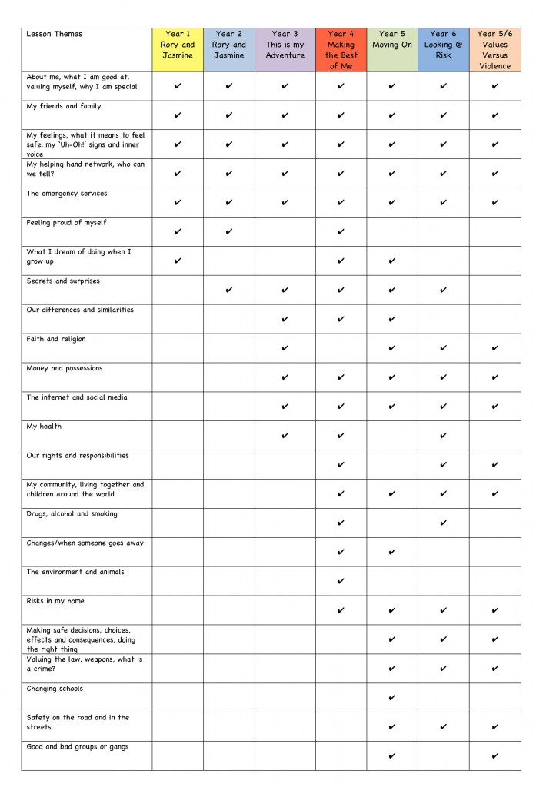
Additional Resources and Websites
Rights Respecting Schools | http://www.unicef.org.uk/
Healthy eating | www.foodafactoflife.org
Healthy eating – food and farming stories | http://www.foodafactoflife.org.uk/section.aspx?t=92&siteId=15&sectionId=101
Bullying | www.childline.org.uk
Abuse and Sexual exploitation | www.barnados.org.uk
Dental hygiene | www.heartyoursmile.co.uk
Water | www.wateraid.org
Water safety | http://www.watersafetykids.co.uk/
Hand washing | www.carex.co.uk/kids-zone
Health and hygiene activities | http://www.atozkidsstuff.com/health.html
Road Safety | www.brake.org.uk
Road Safety – Green Cross Code | http://think.direct.gov.uk/education/early-years-and-primary/
Electrical Safety | http://www.switchedonkids.org.uk/electrical-safety-in-your-home
Railway Safety | http://www.juniorcitizen.org.uk/kids/railsafety/
First Aid for Children | http://www.redcross.org.uk/What-we-do/Teaching-resources/Teaching-packages/Microsite/Life-Live-it-first-aid-education-for-children
Money management | http://pbskids.org/itsmylife/money/managing/ (American but some good ideas)  http://www.moneymatterstome.co.uk/resourcebank.htm
Environment | http://www.timeforkids.com/photos-video/slideshow/plastic-plastic-everywhere/229016  http://ngkids.co.uk/
Safety for kids | http://www.safety4kids.com.au/safety-zone_stranger-danger
Safety for kids | http://www.mcgruff.org/

