Caslon Primary Community School Tel: 01384 818875
Beeches View Avenue, Halesowen, West Midlands, B63 2ES Email: info@caslon.dudley.sch.uk

Head teacher: Mrs Holden-Gough
Weekly Newsletter – 22nd March 2019
Thank you

The Year 1 parents who attend the class assembly.

The Year 3 parents who attended Inspire sessions.

Year 5 and 6 who were very sensible when meeting James Morris MP today, lots of questions were asked.

Rockstar Timetables

A new Rockstar Battle of the bands starts today at 3pm and ends Thursday 28th @3pm. As mentioned and demonstrated at last week's staff meeting, please make sure you've set your class timetables to make sure it is fair. It will be Yr 1 vs Yr 2, Yr 3 vs Yr 4 and Yr 5 vs Yr 6.

Fastest Pupils
Isaiah Sala-Pongo | 1.09 seconds
Kaseem Muflahi | 1.15 seconds
Archie Jones | 1.36 seconds
Isaah Khan | 1.41 seconds
Callum Jones | 1.70 seconds

Top Earners over the past 14 days
Kaseem Muflahi | 81,527 coins
Sami Amar | 49,590 coins
Rayhan Iqbal | 32,664 coins
Laiba Jabeen | 31,991 coins
Isaiah Sala-Pongo | 30,677 coins

Reminders

All children when coming into school, must use the school playground to come in a morning and leave at the end of the day, unless they have permission from Mrs Holden-Gough to go through the main entrance. The main office is for enquires, helping parents, etc.

Please can I encourage you to listen to your children read on a daily basis where possible and record in their reading records. Reading is the key to the world and opens lots of doors for children’s imagination.

Please can I remind you that nobody should be parking on the zigzag lines outside the school gates. This is not a parking or drop of zone and is to ensure the safety of our children.
Can I also remind you that it is great to see so many children coming to school on their bikes and scooters, then please can we ensure they are not riding them on the playground and are sensible in the school surroundings.

Attendance - is vital to a child’s education and please parents can we ask you contact the office on the first day of your child’s absence and if they need to go to the doctors, medical evidence must be provided to ensure a child’s absence is recorded.

Parents Lunches 10th (Reception, Y1 and Y2) and 11th April (Y3, Y4, Y5 and Y6)
This will be available to book your place from Monday 18th March, your place must be booked by the 28th March ready for orders to be placed. It will be a roast dinner (Halal option available) and a selection of puddings, at a cost of £3.63 per adult.
Community Information
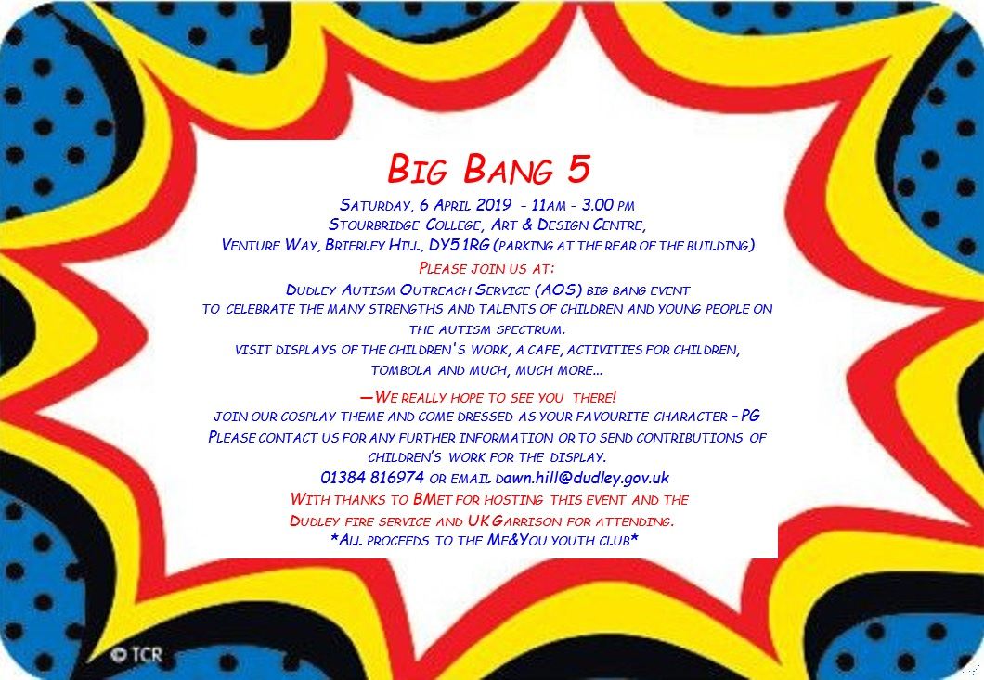

Friends of Caslon Information
29.03.19 | Selling Mother’s Day gifts cost between 50p and £2.50.
03.04.19 | Craft Afternoon this will be available for parents of Year 1 and 2 to book and come to make an Easter Bonnet with child, all resources will be provided even the hat for a cost of £3.50. This will be available until the 29th March to book.
12.04.19 | Easter Coffee Morning @ 9.15am – come & sit, listen to your children sing & have a coffee in great company.
Easter Raffle – Tickets will be on sale through school now 20p a ticket for the Easter Raffle. Various prizes available
07.05.19 | Next Meeting @ 9:00am
18.05.19 | Quiz Evening 6pm, Up to 6 people per team (including children) cost £6.00 to enter, various refreshments available.  If you wish to book a team please do so via emailing:  friendsofcaslon@caslon.dudley.sch.uk

Schoolbuddy
Please can I remind you to book your breakfast club, after school club, lunches for day-care and nursery children as sometimes children arrive without being booked in. If parents continue to book or send children without payments, then we will have to put all places on hold until payments are made. Thank you for your cooperation.
Please book your parents appointment for the 4th April, you will gain a confirmation email to confirm timing, once it is booked and confirm. Mrs Burns will put further information on dojo separate.
Spring/Summer Term – Dates for the Diary
Date | Event
29.3.19 | Mothers’ Day gifts for sale – Friends of Caslon. Items will cost between 50p and £2.50.
3.4.19 | Craft afternoon – Friends of Caslon
4.4.19 | Parents evening – 3.15-7pm
8.4.19 | Reception Class assembly @ 2.30pm
10.4.19 | KS1 & Reception parents lunch
11.4.19 | KS2 parents lunch
12.4.19 | Easter Coffee Morning @ 9.15am – come & sit, listen to your children sing & have a coffee in great company.
12.4.19 | Break up for Easter @ 3pm
29.4.19 | Return to school – House Colour Day
02.05.19 | School is closed for Voting Day
03.05.19 | School is closed for Inset
06.05.19 | School is closed – Spring Bank Holiday
13.05.19 | Sats start for Year 6
18.05.19 | Quiz Evening 6pm – Friends of Caslon
24.05.19 | School breaks up for Whitweek
03.06.19 | Return to school – House Colour Day

