Topic Ideas – Curriculum

Term | Topic
Autumn 1 | Marvellous Me  - Celebrations  - Who Am I?  - My Family  - Where I Live  - Emotions
Autumn 2 | People Who Help Us  - At Home  - In School  - Out and About
Spring 1 | Lay A Little Egg For Me  - Life Cycles  - Animals  - Habitats
Spring 2 | Little Explorers  - Habitats  - Weather  - Space  - Dinosaurs  - Mini Beasts  - Jungles  - Oceans/Pirates
Summer 1 | Mirror, Mirror on the Wall  - Nursery Rhymes  - Fairy tale Stories  - Reflections
Summer 2 | We’re All Going on a Summer Holiday  - Seaside  - Transport  - Airport  - Winter Holidays (for contrast)

Within in all of these topic areas a “LAUNCH” could happen at the beginning in which the topic is presented to the children through an activity (puppet show, letter delivered, hunt to find clues etc) and they have to guess what the topic could be. Children could then be invited to talk about what they would like to explore within that topic and their ideas could be factored into future planning to allow for their interests to be accommodated for.

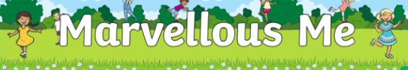

Recognising and writing own name | Using cameras to take photos of themselves and friends | Make a simple family tree and discuss who is in their family | Use computer program to draw pictures of their faces | Asking questions to get to know their friends
Learning routines of the school day | Creating rules for the classroom | Exploring their environment using senses | Explore changes in body when they are active | Look at events that are special to them e.g. birthdays
Exploring different houses | Design and build houses | Look at other occasions that could be special to others | Portraits of themselves and friends | Look at parts of the body and how it works
Book Ideas:
- Guess How Much I Love You  - Funnybones  - Owl Babies  - My Many Coloured Days | - Titch  - Monkey Puzzle  - Elmer

Invite people from local community to share stories and ask questions | Exploring ways we can be safe – road safety, personal safety etc | Role Play – different outfits for children to explore roles | Helping hands – decorate hands with how we can be helpful | Mark making – lists, receipts, doctors notes etc
Explore reflective materials on uniforms | Explore fingerprints and how they help policemen | Make gifts to say thank you to people who help us | Make and decorate emergency vehicles using cardboard boxes | Explore patterns dipping vehicles in paint
Talk about noises vehicles make. Use instruments to make our own sounds | Small world characters to explore narratives
Book Ideas:
- Room on the Broom (helping animals?)

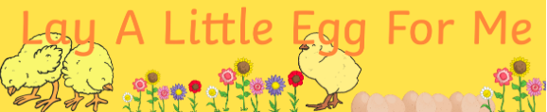

Explore lifecycle of a butterfly – use pasta for different stages | Explore lifecycle of a frog | Explore where eggs and other foods come from | Explore Eric Carle art | Grow sunflowers and explore planting
Explore healthy and unhealthy foods – make Hungry Caterpillar fruit kebabs | Retell and sequence story of Hungry Caterpillar | Role play – garden centre, baby clinic | Move like different animals | Explore changing states – freezing and melting etc
Use iPads to track growth of plants | Explore what happens when we grow – compare baby pictures | Make musical instruments using different seeds | Explore habitats and make our own
Book Ideas:
- The Very Hungry Caterpillar
- The Tiny Seed
- Oliver’s Vegetables

Explore animals habitats – make a bug hotel? | Explore the weather outside – make weather charts, collect rain etc | Explore shadows – create shadow outlines | Make dinosaur fossils out of salt dough | Dig for dinosaur fossils outside in sand
Make maps to find pirate treasure | Look at minibeasts and see if we have any in our Nursery | Go on our own ‘Bear Hunt’ – talk and discuss story | Look at past and present explorers and what they did | Explore different environments e.g. desert, jungle, ocean and what animals live there
Use Google Earth to explore different places | Take photos of us exploring our local environment | Explore animals and the pets children may have | Role play – pirate ship? | Explore the Seasons and changes that we see
Book Ideas:
- We’re Going on a Bear Hunt
- Dear Zoo
- The Gruffalo
- Tyrannosaurus Drip
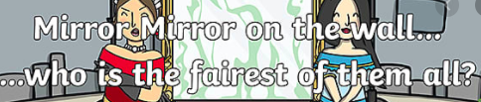

Explore Nursery Rhymes | Junk model to make Humpty Dumpty | Make own Incy Wincy Spider | Role Play - Castles | Look at Castles in the UK and build our own
Make up our own Nursery rhyme | Explore strength of materials – make own wall for HD | Floating and Sinking – Rub A Dub Dub | Look at drain pipes – race cars down them | Look at water cycle
Sing and play instruments to nursery rhymes | Get Well Soon cards for HD | Explore rhyming words and play rhyming games | Make porridge for 3 Bears | Explore materials to make bridges for the Billy Goats Gruff
Book Ideas:
- Nursery Rhymes  - Goldilocks and the Three Bears  - Gingerbread Man | - Jack and the Beanstalk  - Billy Goats Gruff

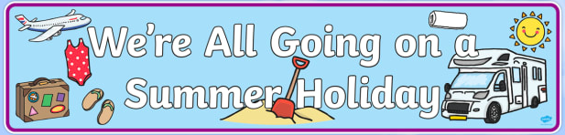

Role play – airport, beach | Mark making – tickets for flights, postcards home | Explore how people travel when they go on holiday | Look at what materials would be best to make a baot | Explore freezing and melting – make own ice lollies
Explore what we would need to pack for hot and cold holidays | Make our own pictures of the beach | Design and pack a suitcase | Look at holiday songs ‘We’re All Going on a Summer Holiday’ etc | Make shadow pictures
Explore shells and use them to make photos | Make and eat our own Teddy Bears Picnic | Make our own sand | Look at Sun Safety and what we need to do to be safe | Explore Seasons
Book Ideas:
- Grandmas Beach
- Herman’s Holiday

