08.06.2020
Dear Parents and Carers of Children due to start Reception in September,
We are delighted that you and your child are joining Caslon Primary Community School this coming September. On behalf of the Staff, Governors, children and parents, it gives me great pleasure to welcome you and your family to our school.
Reception Induction 2020
Ordinarily, we would be writing to you to invite you to a number of events and meetings. However, due to the current situation this is not possible.
We find ourselves in an unprecedented set of circumstances and anticipate the possible anxiety your family may currently feel about your child’s transition into Reception but we would like to assure you that an induction process of some kind will take place; however currently you will understand that we cannot be specific about how and when. Schools are working within a constantly changing environment, with different versions of guidance coming from the DfE on a daily basis. We therefore ask for your patience whilst we put together plans which are practical, flexible and above-all mutually beneficial in supporting the best possible start to your child’s school life.
As tempting as it might be to ring our school office with a list of questions, we ask that you please wait until you hear from us instead. We promise that we will be in touch soon to share our plans for induction once we are clearer about the way forward nationally. We have created a new section on our website with information that you may need, and you can access this here http://www.caslon.dudley.sch.uk/new-reception/
We hope that many of your questions will be answered by visiting the page however, please do not hesitate to email our office on info@caslon.sch.uk if you have an urgent question and we will respond as soon as we can.
We fully understand how worried you might be about your child’s induction but the most important thing at the moment is that you and your child are well and happy; we will be ready to resume learning quickly and positively when this is all over. Please be assured that we are committed to working through this challenging time together.
We will be talking to pre-school and nursery settings, as we always do, to find out where your child is in their learning. We will also be talking to you directly to find out about your child's preferences; things they particularly enjoy, find difficult etc. These conversations usually take place within the context of a stay and play visit to school in July or early September, however if this is not possible, due to the current situation, we will think creatively to ensure that we receive all of the information that we need about your child.
Every single child in the country, that will start Reception in the autumn term, will be in the same position as yours. Our promise to you is that we will continue to work in partnership, to ensure your child’s start to school is both as exciting and positive as we can collectively make it.
We look forward to welcoming you and your child into school once it is safe to do so.
Yours faithfully
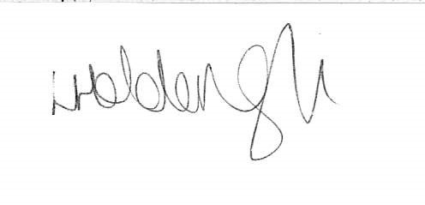
Mrs Holden-Gough
Headteacher

